Name : Dev Adnani  
SID : 202212012

Subject : Systems Programming

Quiz : 01

Q3.

int is_digit(char c) – returns 1 if a given char in c is a digit between 0 to 9; otherwise, return 0.

int is_prime(int no) – returns 1 if no is prim; otherwise, returns 0.

a. Build your static library for the following functions. Test the library functions by calling them from your main program.

b. Now build a dynamic library and test it with the main program.

A: Static Library

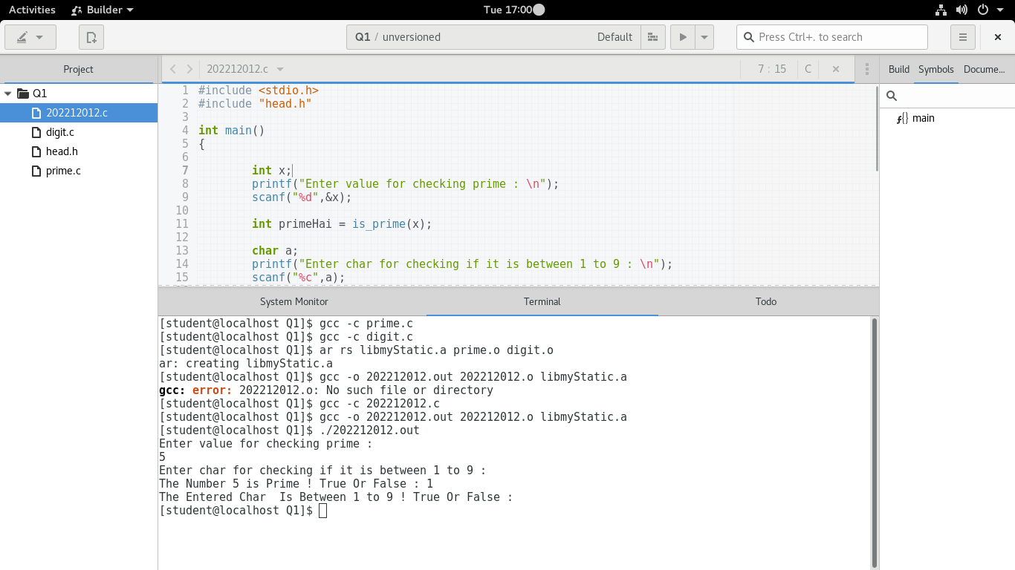  
B: Dynamic Library

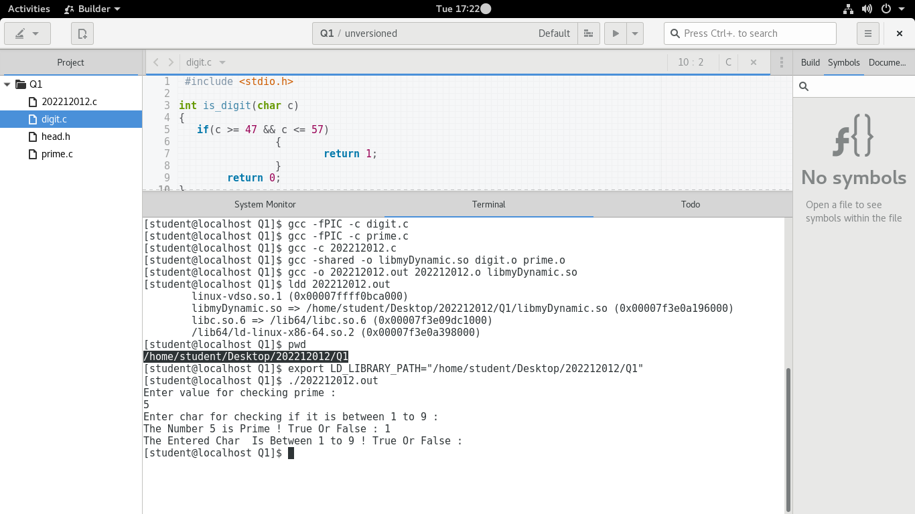

C: Make File Code

CC=gcc

CFLAGS=-I$(IDIR)

IDIR =../include

ODIR=obj

LDIR =../lib

LIBS=-lm

BDIR=../bin

_DEPS = head.h

DEPS = $(patsubst %,$(IDIR)/%,$(_DEPS))

_LIBOBJ = digit.o prime.o

LIBOBJ = $(patsubst %,$(ODIR)/%,$(_LIBOBJ))

_LIBOBJfPIC = digit_fPIC.o prime_fPIC.o

LIBOBJfPIC = $(patsubst %,$(ODIR)/%,$(_LIBOBJfPIC))

LIBSRC = digit.c prime.c

_APPOBJ = 202212012.o

APPOBJ = $(patsubst %,$(ODIR)/%,$(_APPOBJ))

$(ODIR)/digit_fPIC.o: digit.c

$(CC) -c -fPIC -o $@ $< $(CFLAGS)

$(ODIR)/prime_fPIC.o: prime.c

$(CC) -c -fPIC -o $@ $< $(CFLAGS)

$(ODIR)/digit.o: digit.c

$(CC) -c -o $@ $< $(CFLAGS)

$(ODIR)/prime.o: prime.c

$(CC) -c -o $@ $< $(CFLAGS)

$(LDIR)/libmymathdynamic.so:$(LIBOBJfPIC)

$(CC) -shared -o $@ $^

LDLIBPATH:

export LD_LIBRARY_PATH=$$LD_LIBRARY_PATH:$(LDIR)

$(LDIR)/libmymath.a:$(LIBOBJ)

ar rs $@ $^

$(APPOBJ): 202212012.c $(DEPS)

$(CC) -c -o $@ $< $(CFLAGS)

$(BDIR)/static.out: $(APPOBJ)

$(CC) -o $@ $^ $(CFLAGS) $(LDIR)/libmymath.a

$(BDIR)/202212012.out: $(APPOBJ)

$(CC) -o $@ $^ $(CFLAGS) -L$(LDIR)/ -lmymath

$(BDIR)/dynamic.out: $(APPOBJ)

$(CC) -o $@ $^ $(CFLAGS) $(LDIR)/libmymathdynamic.so

$(BDIR)/dynamic.out: $(APPOBJ)

$(CC) -o $@ $^ $(CFLAGS) -L$(LDIR)/ -lmymathdynamic

$(BDIR)/202212012.out: $(LIBOBJ) $(APPOBJ)

$(CC) -o $@ $^ $(CFLAGS)

.PHONY: clean

clean:

rm -f $(ODIR)/*.o *~ core $(INCDIR)/*~

rm -f $(BDIR)/*.out $(LDIR)/*